Mirage: SQ Strategy for
Green on Screen

Contents:

1. Purpose of this document
2. Green on Screen
3. Functionalities in Green on Screen
3.1 Frequency Screen
3.2 Channel Screen
3.3 Basic Marker
3.4 Linear Spectrum
3.5 Time View
3.6 Start Stop – Data Acquisition
3.7 LAN SCPI
4. Strategy
5. How SQ team is going to test Green on Screen
5.1 Front Panel Testing
5.2 GUI Testing
5.3 Functional Testing
5.4 Measurement Testing
5.5 SCPI Testing
6. Resources and Scheduling
7. Risks involved

1. Purpose of this document

This document describes the SQ team’s plan for ensuring the software quality of “Mirage-Green on Screen”. This plan addresses the functionalities which are to be tested, strategy, detailed testing methods, required resources (people, hardware, software, etc.). Other then this, this document contains links for all other documents which are required for performing testing on Green on Screen.

2. Green on Screen

Green on Screen is the first integration of Mirage software and Hardware. After this integration we will be able to see working of front panel buttons and their response on the hardware screen.
In this all soft-keys and all hard-keys will be working and the functionality which is achieved is discussed in next section.

3. Functionalities available on Green on Screen

3.1 Frequency Screen
3.2 Channel Screen
3.3 Basic Marker
3.4 Linear Spectrum
3.5 Time View
3.6 Start Stop – Data Acquisition
3.7 LAN SCPI
- Trace Control,
- Data Extraction,
- Frequency and Channel Configuration

Frequency Screen: This screen provides the various frequency setting and also allows changing them.
- The frequency configuration page appears on pressing “Alt + F” key on the keyboard.
- The frequency accelerators allow changing the frequency parameters directly. When any of the frequency parameter is changed via the accelerator then other frequency parameters changes accordingly.
- Various custom controls used in this frequency screen should exhibit their individual behavior as above.

Channel Screen: This screen provides the various channel setting and also allows changing them.
- The channel configuration page appears on pressing “Alt + C” key on the keyboard.
- The channel accelerators allow changing the channel parameters directly.
- Various custom controls used in this channel screen should exhibit their individual behavior as above.
- Soft Key 1: “Working Channel”; we can select the Working Channel from a Combo Box; and the remaining Soft key Accelerators should get refreshed showing the Channel settings for that particular Channel. There are four working Channels :
- 1
- 2
- 3
- 4

- Soft key 2: “Configure Channel...” The Configure Channel screen should appear showing Channel Parameters for the particular Channel selected through Soft key 1.
- Soft key 3: “Window” is used to change the Window Type of the Working Channel from a Combo Box and save the settings in Instrument Proxy.
- Soft Key 4: “Coupling” is used to change the Coupling Type from a Dual state Accelerator Type .Clicking should toggle the value between “AC” and “DC” and set the selected value in the Instrument Proxy.
- Soft Key 5: “Weight Filter” is used to Change the Filter Type from a Combo Box and set the selected Value in Instrument Proxy.
- Soft Key 6: “Voltage Range” is used to change the Voltage Range from a Combo Box and set the selected value in the Instrument Proxy.
- Soft Key 7: “Active Ref Channel” is used to Change the Active Ref Channel for the System. This parameter does not appear in the Configure Channel Screen.

Complete details of these functionalities are available at TFS\Documents\QA\Release Notes\UIControlReleaseNotes.doc” and Details of LAN SCPI’s are available at
TFS\Documents\QA\SCPI's behavior.doc

4. Strategy
SQ team will have Release documents, Functionality documents, GUI standard documents, Measurement and SCPI testing plan and infrastructure. These all documents, testing infrastructure, test plans and test tools will be ready and checked in before release of Green on Screen and we will follow below mentioned points while executing our test plans.

- On the basis of functionality and modules we will divide testing of Mirage into following blocks:
  - Front panel testing
  - GUI testing
  - Functionality testing
  - Measurement testing
  - SCPI testing

- We will have a clear plan to test each n every block defined in above mentioned point and before release of Green on Screen testing infrastructure to test these blocks will be ready. These plans will be described in next section.

- Initially the quality of Front panel will be tested, if Front panel is working fine then we will move on to GUI testing and a less effort will be delivered in this since it has been done twice before then we will divide Functionality testing among QA Engg. and in the last Measurement testing and SCPI testing will be performed.
SCPI Testing
GUI Testing
Front Panel Testing
Functional Testing
Time
Effort
Measurement Testing

- We will start from manual testing, Front Panel and Functional testing will be done manually and then we will try to automate GUI testing through “VNC served FP integration with Proto UI”.

- All engg. will start from Front Panel testing and they will have daily standing meetings regarding bugs found so that they can eliminate duplicate bugs. After FP testing one engg. will move to GUI testing and 2 will work on Functional testing and later on all 3 will be testing functionality(since GUI testing will not take much time). After this one engg. will perform SCPI testing and two engg. will perform Measurement testing.

- SQ Team would be analyzing type of defects found in FP Testing to have an idea about "FP risky” zones so that they can work proactively to do additional FP testing to reduce the risk and finding out the right Coverage for our Automated Test Runs.

- Manual test case file has a separate sheet – “RiskyZones”, this sheet will have Release Vs Areas which are defect prone. This file is available at TFS\Documents\QA.

- Display/Graphics Verification Tests - This type of FP test is meant to verify the quality of the “Display/Graphics” parameters and to verify that our Display Design is consistent during DEV cycle.

- After performing complete testing on Green on Screen SQ team will have a retrospective meeting, in this meeting SQ team will discuss:
- What were the areas we were not able to cover in this plan?
- What we should leave from this plan?
- Identify Risky areas and in next plans put extra effort on them.

5. How SQ team is going to test Green on Screen

5.1 Front Panel testing (Manual) – A tester will press buttons on Front Panel and he will see the response on screen whether buttons are working properly or not, whether text on soft keys is changing or not etc. To achieve this SQ team has test cases for all hard keys and soft keys, this test case document has taken Mirage Prototype as a reference. (FrontPanel_Testing.xls)

5.2 GUI Testing: Initially GUI testing will be performed manually for this we have GUI standard checklist, this checklist is available at TFS\Documents\QA\GUI Standards\GUI_Checklist.pdf. To automate GUI testing we will use “VNC served FP integration with Proto UI” and Rational Robot.
“VNC served FP integration with Proto UI” is an internally (in house) developed tool this will show screen of Mirage hardware on a computer and then that can be tested automatically via Rational Robot.

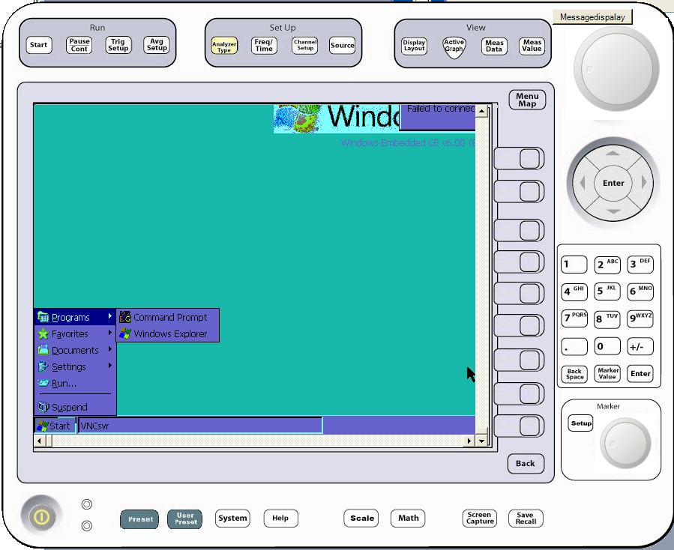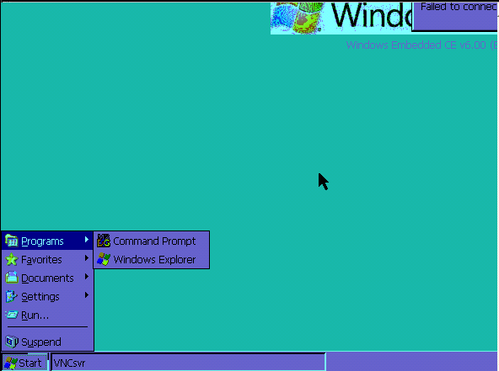
Proto UI
Mirage Instrument
Send Screen
Command
Cmd Server
VNC Screen Server

SQ team has created a document on how to run and maintain this tool. (VNC served FP integration with Proto UI.doc). Complete design is available in this document.

5.3 Functionality Testing: The complete functionality of the Green on screen will be tested manually, to achieve this we have written functional test cases and the test case file has been checked in into the source control system, the other informative documents are also checked in with in the system and their details are available in previous sections of this document. (Functional_Test_Cases.xls)

5.4 Measurement Testing: We have a plan to create some .csv files which will act as input for MatLab and Mirage-AML block, the MatLab program’s design will be similar to AML’s design so that we can check data at every point. The two modules MatLab’s program and Mirage’AML will process the .csv file and store the output in the same directory then these two outputs will be compared and the result will be saved in Test_Result.xls file.

CSV File
MatLab
O/P 1
AML / Measurement
O/P 2
Different Possible I/Ps
Mirage
For Comparison
Program with design similar to AML

All information regarding this plan has been stored in Measurement_Testing_Plan.doc and
Measurements we are going to test in Green on Screen are kept at TFS\Documents\QA\GreenOnScreenMin_Functional_Req.xls

5.5 SCPI Testing: (Automated SCPI testing) Mirage could be controlled via LAN SCPI’s, for this we have a set of SCPI’s. For Green on Screen we have following set of SCPI’s:
- Trace configuration
- Data Extraction
- Frequency and channel configuration SCPI
We are going to automatically test SCPI’s by NI-TestStand, We have plan to write separate projects for SCPI’s syntax testing and SCPI’s functional testing, infrastructure is ready for this and we have to write some TestStand-sequence files in order to perform automated testing.
The complete information regarding these SCPI’s is available at TFS\Documents\QA\SCPI_Testing\SCPI's behavior.doc, besides this we do have SCPI_Testing.xls file, this file contains a SCPI reference sheet and all test cases that can be executed on SCPI’s for checking their proper functioning. And this sheet will act as a reference for SCPI testers.
We have created a “Mirage SCPI Testing.doc” document, this document has complete plan and set of rules which must be followed while automatically testing SCPI’s.

6. Resources and Scheduling:

Required Software and Hardware: We may require following software/hardware for Green on Screen testing
- NI TestStand
- Rational Robot
- MatLab
- VNC served FP integration with Proto UI
- Mirage Hardware

Required Documents:
- TFS\Documents\QA\SCPI_Testing\SCPI_Test_Cases.xls
- TFS\Documents\QA\SCPI_Testing\SCPI's behavior.doc
- TFS\Documents\QA\SCPI_Testing\Mirage SCPI Testing.doc
- TFS\Documents\QA\Measurement_Testing_Plan.doc
- TFS\Documents\QA\GreenOnScreenMin_Functional_Req.xls
- TFS\Documents\QA\GUI Standards\GUI_Checklist.pdf
- TFS\Documents\QA\Release Notes\UIControlReleaseNotes.doc
- TFS\Documents\QA\Functionality_Test_Cases.xls
- TFS\Documents\QA\FrontPanel_Test_Cases.xls
- TFS\Documents\QA\VNC served FP integration with Proto UI.doc

Following engg are going to work on Green on Screen testing:
Vasav Tyagi
Rajender Mehta
Shashi Prakash

For Measurement testing and SCPI testing we have plan and infrastructure but we need to make some TestStand Sequence files and Matlab program files. SQ Team will start writing those from 1st Oct. 2008. Writing SCPI sequence files will take approximately 2 weeks so they will be ready by 15thOct2008. (SQ team has dependency on development team).
All engg. will start from Front Panel testing and they will have daily standing meetings regarding bugs found so that they can eliminate duplicate bugs. After FP testing one engg. will move to GUI testing and 2 will work on Functional testing and later all 3 will be testing functionality(since GUI testing will not take much time). After this Vasav will perform SCPI testing and Rajender and Shashi will perform Measurement testing.

7. Risks involved
Measurement Testing could be a big risk in this plan and the reason for this are:
- Inadequate expertise in MatLab
- Less amount of time

To avoid failure of Measurement testing plan we have to make a priority list of all measurements and we will start writing/verifying* MatLab programs from high priority to low priority measurements and its progress should be checked on daily bases so that we can modify our measurement testing strategy instantaneously.

* Since Measurement team has already written some MatLab programs so in some cases only verification will be required.

